**Solution of Word Problems using Gauss-Jordan Method**

**Example 1**

Ali and Sara are shopping for chocolate bars. Ali observes, “If I add half my money to yours, it will be enough to buy two chocolate bars.” Sara naively asks, “If I add half my money to yours, how many can we buy?” Ali replies, “One chocolate bar.” How much money did Ali have?

**Solution:** Let a = Ali’s money

s = Sara’s money

c = Cost of chocolate

$$\left\{\begin{aligned}\frac{1}{2}a+s=2c----→(1) \\ a+\frac{1}{2}s=c-----→(2)\end{aligned}\right.$$

Or $\left\{\begin{aligned}a+2s=4c \\ 2a+s=2c\end{aligned}\right.$

The augmented matrix is

$$\left[\begin{matrix}1 & 2 & 4c \\ 2 & 1 & 2c\end{matrix}\right]$$

$\left[\begin{matrix}1 & 2 & 4c \\ 0 & -3 & -6c\end{matrix}\right]$ ~~~~~~~~~~~ $R_{2}-2R_{1}$

$\left[\begin{matrix}1 & 2 & 4c \\ 0 & 1 & 2c\end{matrix}\right]$ ~~~~~~~~~~~ $-\frac{1}{3}R_{2}$

$\left[\begin{matrix}1 & 0 & 0 \\ 0 & 1 & 2c\end{matrix}\right]$ ~~~~~~~~~~~ $R_{1}-2R_{2}$

Solution is $(a, s)=(0, 2c$). It means Ali has no money.

**Example 2**

Three Alto, two Suzuki, and four City can be rented for $106 per day. At the same rates two Alto, four Suzuki, and three City cost $I07 per day, whereas four Alto, three Suzuki, and two City cost $102 per day. Find the rental rates for all three kinds of cars?

**Solution:**

$$3a+2s+4c=106$$

$$2a+4s+3c=107$$

$$4a+3s+2c=102$$

Its Augmented matrix is

$$\left[\begin{matrix}3 & 2 & \begin{matrix}4 & : 106\end{matrix} \\ 2 & 4 & \begin{matrix}3 & : 107\end{matrix} \\ 4 & 3 & \begin{matrix}2 & : 1\end{matrix}02\end{matrix}\right]$$

$\left[\begin{matrix}1 & -2 & \begin{matrix}1 & : -1\end{matrix} \\ 2 & 4 & \begin{matrix}3 & : 107\end{matrix} \\ 4 & 3 & \begin{matrix}2 & : 1\end{matrix}02\end{matrix}\right]$ ~~~~~~~~~~~ $R_{1}-R_{2}$

$\left[\begin{matrix}1 & -2 & \begin{matrix}1 & : -1\end{matrix} \\ 0 & 8 & \begin{matrix} 1 & : 109\end{matrix} \\ 4 & 3 & \begin{matrix}2 & : 1\end{matrix}02\end{matrix}\right]$ ~~~~~~~~~~~ $R_{2}-{2R}_{1}$

$\left[\begin{matrix}1 & -2 & \begin{matrix}1 & : -1\end{matrix} \\ 0 & 8 & \begin{matrix} 1 & : 109\end{matrix} \\ 0 & 11 & \begin{matrix}-2 & : 1\end{matrix}06\end{matrix}\right]$ ~~~~~~~~~~~ $R_{3}-{4R}_{1}$

$\left[\begin{matrix}1 & -2 & \begin{matrix}1 & : -1\end{matrix} \\ 0 & -3 & \begin{matrix} 3 & : 3\end{matrix} \\ 0 & 11 & \begin{matrix}-2 & : 1\end{matrix}06\end{matrix}\right]$ ~~~~~~~~~~~ $R_{2}-R_{3}$

$\left[\begin{matrix}1 & -2 & \begin{matrix}1 & : -1\end{matrix} \\ 0 & 1 & \begin{matrix}-1 & : -1\end{matrix} \\ 0 & 11 & \begin{matrix}-2 & : 1\end{matrix}06\end{matrix}\right]$ ~~~~~~~~~~~ $-\frac{1}{3}R_{3}$

$\left[\begin{matrix}1 & -2 & \begin{matrix}1 & : -1\end{matrix} \\ 0 & 1 & \begin{matrix}-1 & : -1\end{matrix} \\ 0 & 0 & \begin{matrix}9 & : 95\end{matrix}\end{matrix}\right]$ ~~~~~~~~~~~ $R_{3}-{11R}_{2}$

$\left[\begin{matrix}1 & 0 & \begin{matrix}-1 & : -3\end{matrix} \\ 0 & 1 & \begin{matrix}-1 & : -1\end{matrix} \\ 0 & 0 & \begin{matrix}9 & : 117\end{matrix}\end{matrix}\right]$ ~~~~~~~~~~~ $R_{1}+2R_{2}$

$\left[\begin{matrix}1 & 0 & \begin{matrix}-1 & : -3\end{matrix} \\ 0 & 1 & \begin{matrix}-1 & : -1\end{matrix} \\ 0 & 0 & \begin{matrix}1 & : 13\end{matrix}\end{matrix}\right]$ ~~~~~~~~~~~ $\frac{1}{9}R_{3}$

$\left[\begin{matrix}1 & 0 & \begin{matrix}0 & : 10\end{matrix} \\ 0 & 1 & \begin{matrix}-1 & : -1\end{matrix} \\ 0 & 0 & \begin{matrix}1 & : 13\end{matrix}\end{matrix}\right]$ ~~~~~~~~~~~ $R_{1} +R_{3}$

$\left[\begin{matrix}1 & 0 & \begin{matrix}0 & : 10\end{matrix} \\ 0 & 1 & \begin{matrix}0 & : 12\end{matrix} \\ 0 & 0 & \begin{matrix}1 & : 13\end{matrix}\end{matrix}\right]$ ~~~~~~~~~~~ $R_{2} +R_{3}$

Hence, the rental rates for Alto, Suzuki, and City cars are $\$10, \$12 and \$13$ per day, respectively.

**Example 3**

A restaurant owner plans to use x tables seating 4, y tables seating 6 and z tables seating 8, for a total 20 tables. When fully occupied, the tables seat 108 customers. If only half of the x tables, half of the y tables and one-fourth of the z tables are used, each fully occupied, then 46 customers will be seated. Find x, y, and z.

**Solution:**

$$x+y+z=20$$

$$4x+6y+8z=108$$

$$4\left(\frac{x}{2}\right)+6\left(\frac{y}{2}\right)+8\left(\frac{z}{4}\right)=46$$

Simplifying the system, we have

$$x+y+z=20$$

$$2x+3y+4z=54$$

$$2x+3y+2z=46$$

.

.

.

**The answer is: $x=10, y=6 and z=4$**

**Work to do:**

**Q1.** Students are buying books for the new semester. Asma buys the linear algebra book and the differential equation book for $178. Aiman, who is buying books for herself and her friend, spends $319 on two linear algebra books, one differential equation book, and one educational psychology book. Sara buys the educational psychology book and the differential equation book for $147 in total. How much does each book cost?

**Q2.** A soap manufacturer wants to spend 60 Lac rupees on radio, magazine, and TV advertising. If he spends as much on TV advertisement as on magazines and radio together, and the amount spend on magazines and TV combined equals 5 times that spent on radio, what is the amount to be spent on each type of advertising?

**Q3.** Three merchants find a purse lying in the road. One merchant says “If I keep the purse, I shall have twice as much money as the two of you together”. “Give me the purse and I shall have three times as much as the two of you together”, said the second merchant. The third merchant said, “I shall be much better off than either of you if I keep the purse, I shall have five times as much as the two of you together.” If there are 60 coins (of equal value) in the purse, how much money does each merchant have?

**Words Problems related to Infinite Solutions**

**Question 1**

Ihave 32 bills in my wallet, in the denominations of US $ 1, 5 and 10, worth $100 in total. How many do I have of each denomination?

**Solution:** Let x = no. of 1$ bills, y = no. of 5$ bills, z = no. of 10$ bills.

System looks like:

$$\left\{\begin{aligned}x+y+z=32---→\left(1\right) \\ x+5y+10z=100--→\left(2\right)\end{aligned}\right.$$

The augmented matrix is

$$\left[\begin{matrix}1 & 1 & 1 :32 \\ 1 & 5 & 10 :100\end{matrix}\right]$$ $\left[\begin{matrix}1 & 1 & 1 :32 \\ 0 & 4 & 9 :68\end{matrix}\right]$ ~~~~~~~~~~~ $R_{2}-R_{1}$

$\left[\begin{matrix}1 & 1 & 1 :32 \\ 0 & 1 & \frac{9}{4} :17\end{matrix}\right]$ ~~~~~~~~~~~ $\frac{1}{4}R_{1}$

$\left[\begin{matrix}1 & 0 & -\frac{5}{4} :15 \\ 0 & 1 & \frac{9}{4} :17\end{matrix}\right]$ ~~~~~~~~~~~ $R_{1}-R_{2}$

Here $x, y, z$ should be positive integers. Now we see the conditions on z or t.

* First of all, let $z=t$ should be multiple of 4.
* Further $z$ must be positive and $y=17-\frac{9}{4}t$ must be positive as well.

$t=4, 8, 12, 16………$

Only $t=4$ works here, which gives $z=4$ and

$x=15+\frac{5}{4}\left(4\right)=20$, $y=17-\frac{9}{4}\left(4\right)=8$.

So I have 20 one dollar bills, 8 five dollar bills, and 4 ten dollar bills.

**Question 2** Ali is getting some flowers for his office. Being of a precise analytical mind, he plans to spend exactly $24 on a bunch of exactly two dozen flowers. At the flower market they have lilies ($3 each), roses ($2 each), and daisies ($0.50 each). Ali loves lilies, what is he to do?

**Solution: $3l+2r+0.5d=24$**

$$l + r+ d=24$$

Its Augmented matrix is

$$\left[\begin{matrix}6 & 4 & \begin{matrix}1 & : 48\end{matrix} \\ 1 & 1 & \begin{matrix}1 & : 24\end{matrix} \end{matrix}\right]$$

**.**

**.**

**.**

**Question 3**

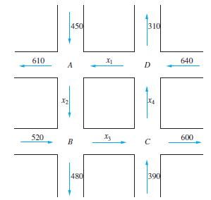In the downtown section of a certain city, two sets of one-way streets intersect as shown in Figure below. The average hourly volume of traffic entering and leaving this section during rush hour is given in the diagram. At each intersection, the number of automobiles entering must be the same as the number leaving.

1. Determine the amount of traffic between each of the four intersections.
2. The amount of traffic between intersections C and D averages 200 automobiles. Please find the amount of traffic for other intersections.

**Solution:** A: $x_{1}+450=x_{2}+610$

B: $x_{2}+520=x_{3}+480$

C: $x_{3}+390=x_{4}+600$

D: $x_{1}+310=x_{4}+640$

.

.

.

$$\left[\begin{matrix}1 & 0 0 & -1:330 \\ 0 & 1 0 & -1:170 \\ 0 & 0 1 & -1:210 \\ 0 & 0 0 & 0: 0\end{matrix}\right]$$

The solution is $x_{1}=$ t+330, $x_{2}=$ t+170, $x_{3}=$ t+210, $x_{4}=$ t.

(b) Hence, for $x_{4}=200$, amount of traffic for other intersections is $x_{1}=5$ 30, $x_{2}=$ 370, and $x_{3}= 4$ 10.

**Work to do:**

**Question 4**

Some parking meters in Milan, Italy, accept coins in the denominations of 20c, 50c, and €2. As an incentive program, the city administrators offer a big reward (a brand new Ferrari Testarossa) to any meter maid who brings back exactly 1,000 coins worth exactly € 1,000 from the daily rounds. What are the odds of this reward being claimed anytime soon?

**Question 5**

The new animated feature film is now playing 3 times a day in DHA Cinema. One day, there were 20 adults, 30 children and 10 senior citizens and theater made $600. At the next showing there were 20 adults, 48 children and 20 senior citizens with the theater making it $800 in ticket sale. At the last showing theater made $400 with 10 adults, 30 children and 5 senior citizens. How much are the tickets at the movie theater?

**Question 6**

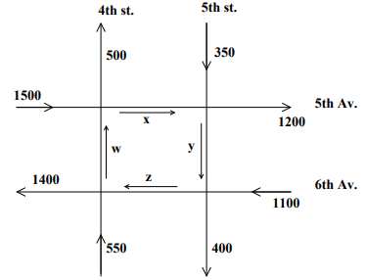The accompanying figure shows the flow of downtown traffic in a certain city during rush hours on a typical weekday. The arrows indicate the direction of traffic flow on each one–way road, and the average number of vehicles entering and leaving each intersection per hour appears beside each road. Fifth and Sixth Avenues can handle up to 2000 vehicles per hour without causing congestion, whereas the maximum capacity of each of the two streets is 1000 vehicles per hour. The flow of traffic is controlled by traffic lights installed at each of the four intersections.

(a) Set up the system of equations that would model this problem.

(b) Solve the system of equations and write the answer in parametric form. Place restrictions on the parameter.

(c) Find two possible flow patters that would ensure that there is no traffic congestion.

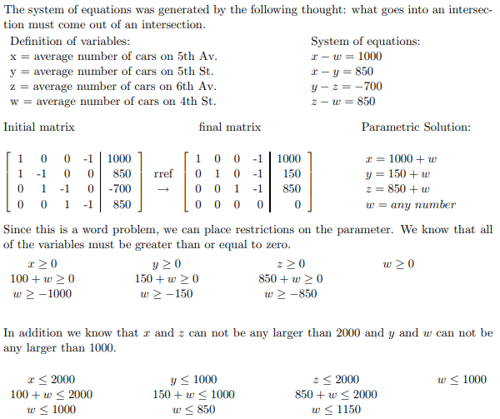





When all of these restrictions are considered, we find that in order to have a valid solution, we need the restriction on the parameter to be 0 ≤ *w* ≤ 850.